NOTÍCIAS FEIRA DA AGRICULTURA FAMILIAR– DEZEMBRO

FONTE: https://www.instagram.com/p/CltyJixuU6t/

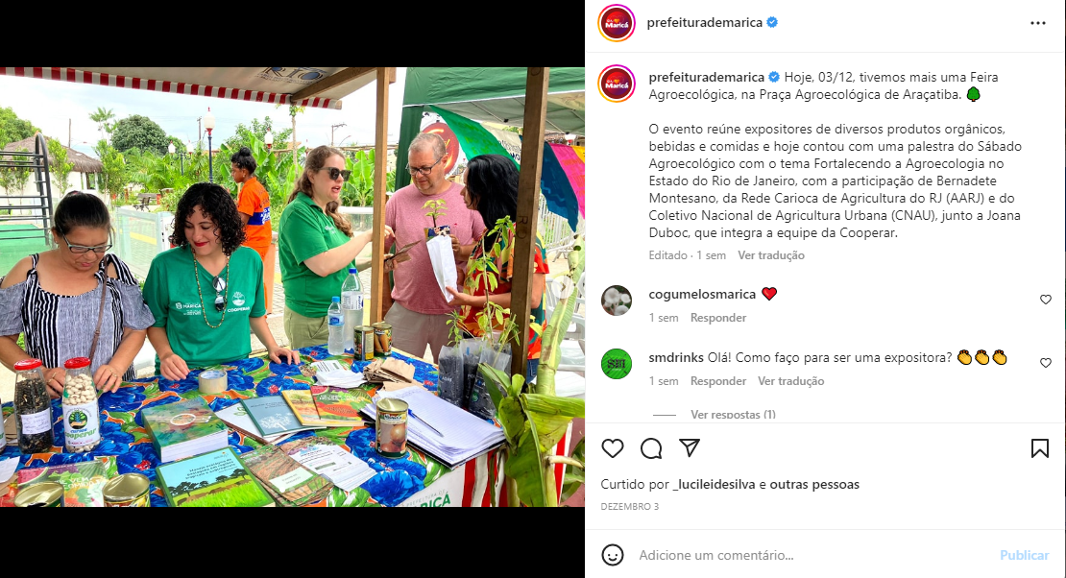

FONTE: https://www.instagram.com/p/CllsC-HOAYi/
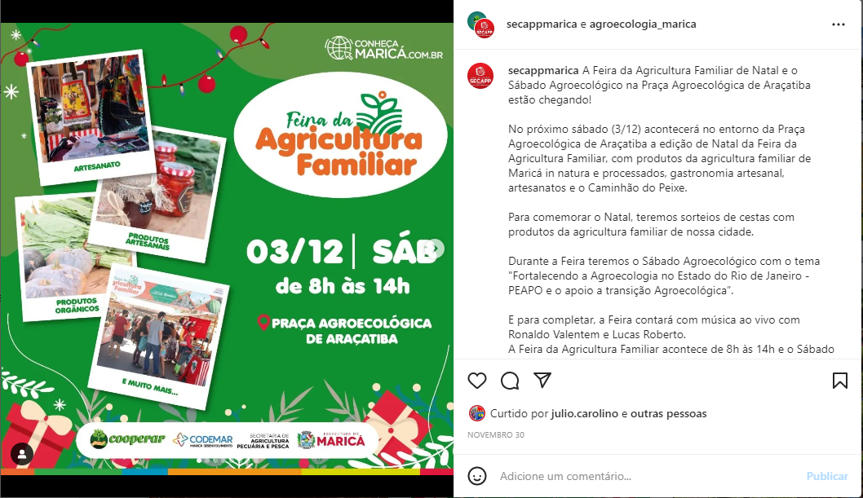

Fonte: https://www.instagram.com/p/CloHdbusHar/
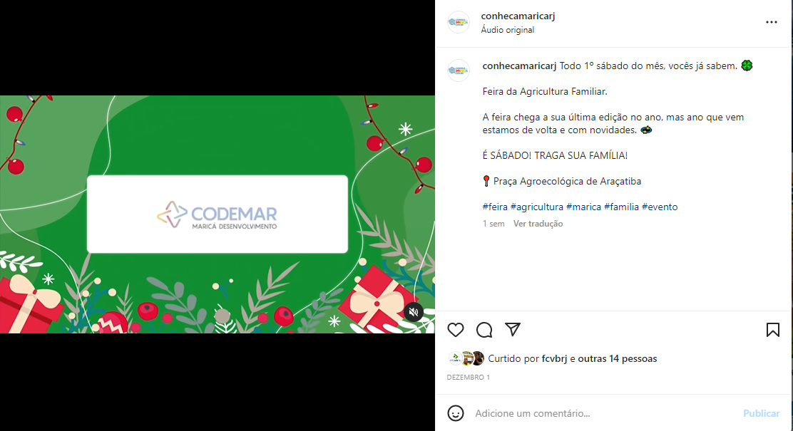

Fonte: https://www.facebook.com/prefeiturademarica/posts/pfbid0TdJBytqNcJSvhXpHkJd8BEGwkttoX3PVkLZMUN6ML6KjR861nFoKpbuXV2HgDy7Ul
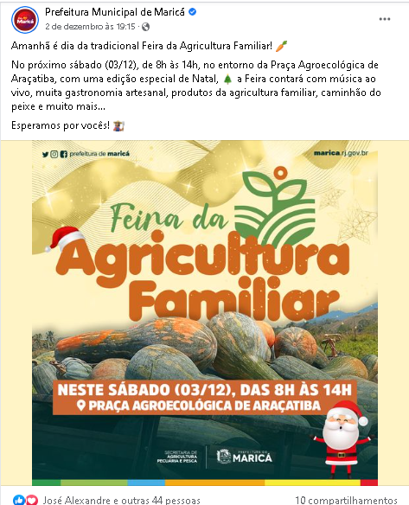

Fonte: https://www.facebook.com/prefeiturademarica/posts/pfbid02hkos5VU1fKvSR5PiTd5bce8ba1usHNko6mkE11YJbiPwEQwtMvf4yg5r3Bvn8wTXl
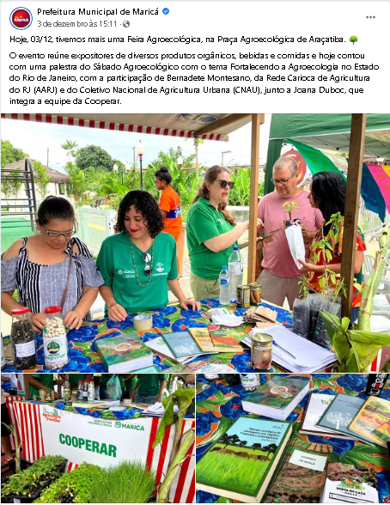

Fonte: https://www.facebook.com/secretariadeagriculturademarica/posts/pfbid02HhRxz1DbtFmyLgbToqWYP1zDbUcxiUmhf2YX9LPbAK1fH1M5FYcZe8XHHVZKNCial
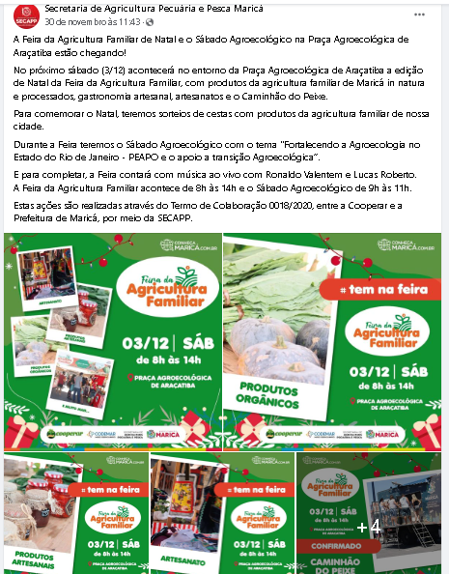

Fonte: https://www.facebook.com/secretariadeagriculturademarica/posts/pfbid02XbBbKHeoPq3H3nJs9F31qZUivVSo9eMxNR2pT4562tCstsFTPRLJDZq5g9YLzJA9l
