**CLIPPING DE NOTÍCIAS –** **CIRCUITO MARICÁ DE PESCA ESPORTIVA E AMADORA**

**FONTE:** <https://www.instagram.com/p/C476YDJulIZ/>

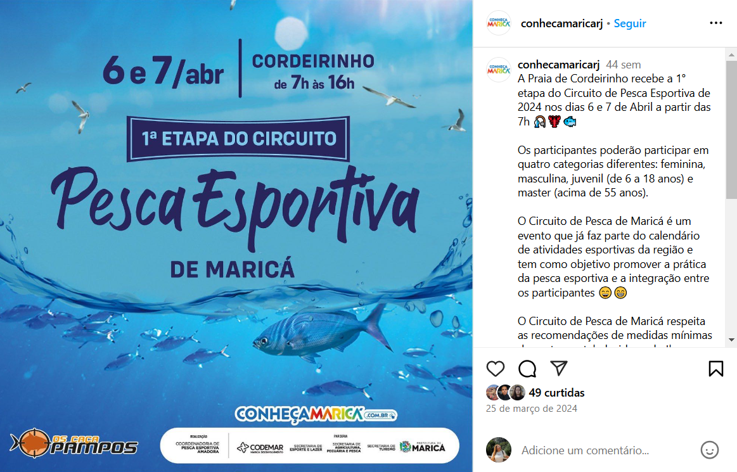

**FONTE:** <https://www.facebook.com/coordenadoriadepesca/posts/pfbid0CovRqvygQ3UNArSSwomuX7xZBuWUgvBPT1CJmKF2JkAxuPiTiCJAaF3wzu7K1CYdl>

**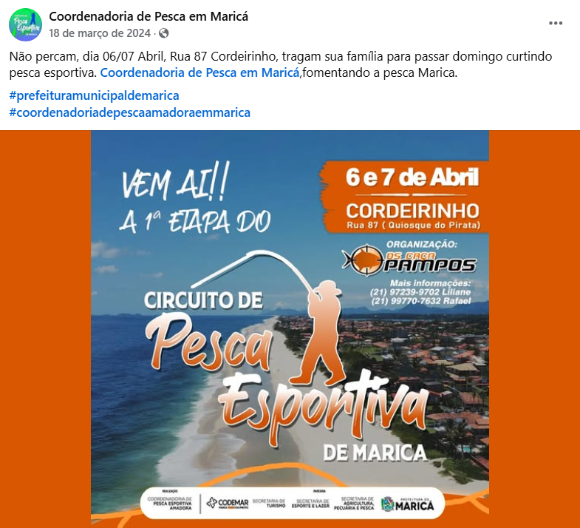  
**

**FONTE:** [https://www.facebook.com/coordenadoriadepesca/posts/pfbid02pmizZTm7tyjhMuDPMB4npBJcfUgTQ1LMuAmYwkocaXyKwZb6FoajZz2Agzdwebsfl?__cft__[0]=AZUazQqXDbc3rfeLOQlv9zRXqCjpPq-vzobHJyFOQka1ewN7gQEs7q0bfmqDt2fpEcBibgPQPlMPWmWzyenZedssZRbvSvUC58XsgduOIL1q_Ltz0zRF1UOrulFr8NbGLld0Ja8CqLoH-2C95dMvZ8K5KODkaF3SGahcP-zey2F_RA&__tn__=%2CO%2CP-R](https://www.facebook.com/coordenadoriadepesca/posts/pfbid02pmizZTm7tyjhMuDPMB4npBJcfUgTQ1LMuAmYwkocaXyKwZb6FoajZz2Agzdwebsfl?__cft__%5b0%5d=AZUazQqXDbc3rfeLOQlv9zRXqCjpPq-vzobHJyFOQka1ewN7gQEs7q0bfmqDt2fpEcBibgPQPlMPWmWzyenZedssZRbvSvUC58XsgduOIL1q_Ltz0zRF1UOrulFr8NbGLld0Ja8CqLoH-2C95dMvZ8K5KODkaF3SGahcP-zey2F_RA&__tn__=%2CO%2CP-R)

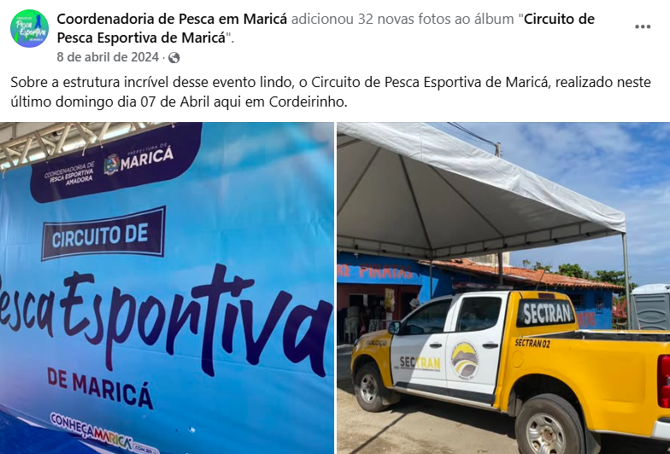  
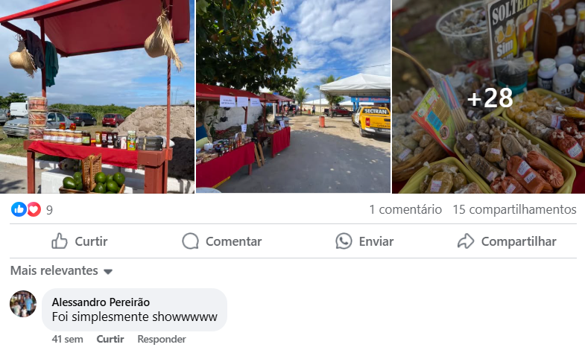

**FONTE:** <https://www.facebook.com/marcelo.martins.393/posts/pfbid0Wn7ZwzQwq5GA1Pu6NP74vtmawhyfUkdCdbBaZ5LtiU3qLsMvRmXTbqcEDKBSkeggl>

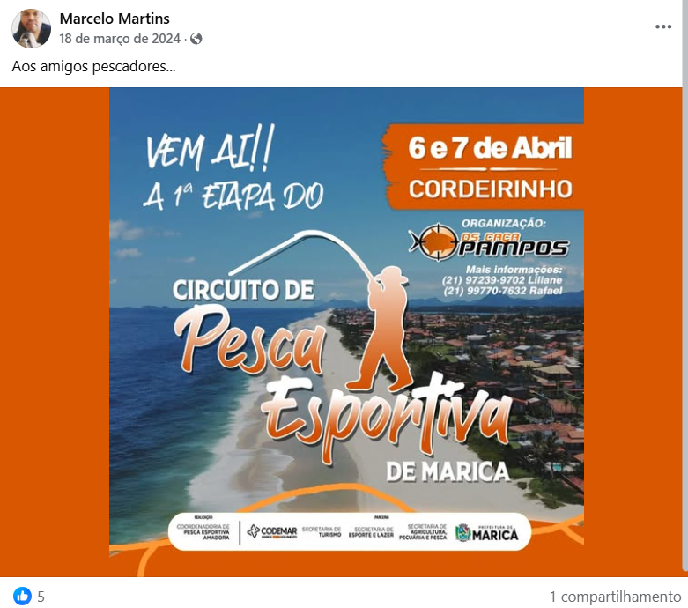

**FONTE:** [https://www.facebook.com/reel/1941265659608985/?s=single_unit&__cft__[0]=AZWMXRk1BAodziu0tsR1O3O2VfV4PtniToe0-qqAVOMYhlrN1y74p8zNDv1RlO1pTr7wo7KKoZ-9YX4OmIsLuJmHdYqHn9-FQ5qJqDOZGlBm4-eLaP4zd9_lm8yyKTQgEOZpO12wvDpm9vpyXCyXBOc_riQFHSMw24ZxQ0ztfVWXwp8CV6jjU6Jlfek5i5WCRjQ1lPYdYmu91nozw_xYJ_7L&__tn__=H-R](https://www.facebook.com/reel/1941265659608985/?s=single_unit&__cft__%5b0%5d=AZWMXRk1BAodziu0tsR1O3O2VfV4PtniToe0-qqAVOMYhlrN1y74p8zNDv1RlO1pTr7wo7KKoZ-9YX4OmIsLuJmHdYqHn9-FQ5qJqDOZGlBm4-eLaP4zd9_lm8yyKTQgEOZpO12wvDpm9vpyXCyXBOc_riQFHSMw24ZxQ0ztfVWXwp8CV6jjU6Jlfek5i5WCRjQ1lPYdYmu91nozw_xYJ_7L&__tn__=H-R)

