**CLIPPING DE NOTÍCIAS – CIRCUITO DE PESCA ESPORTIVA NOVEMBRO**

**FONTE:** <https://www.instagram.com/conhecamaricarj/p/DCEi1Sku7T_/?img_index=1>

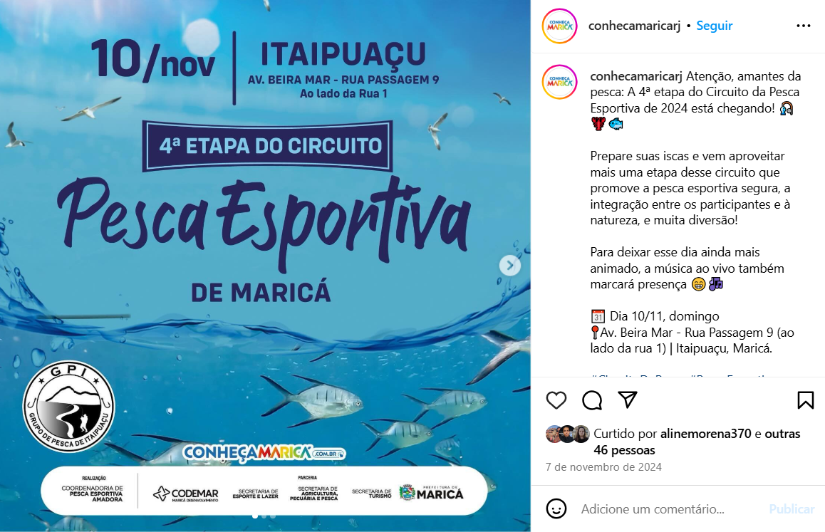

**FONTE:** <https://www.facebook.com/story.php?story_fbid=948252850679023&id=104031155080670&_rdr>

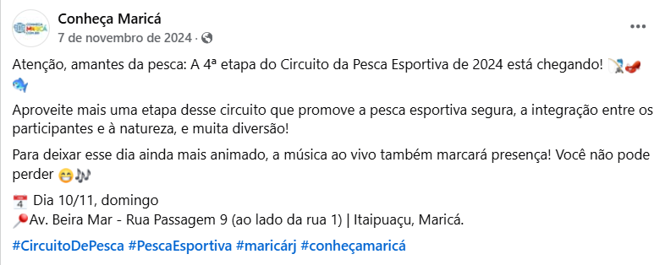

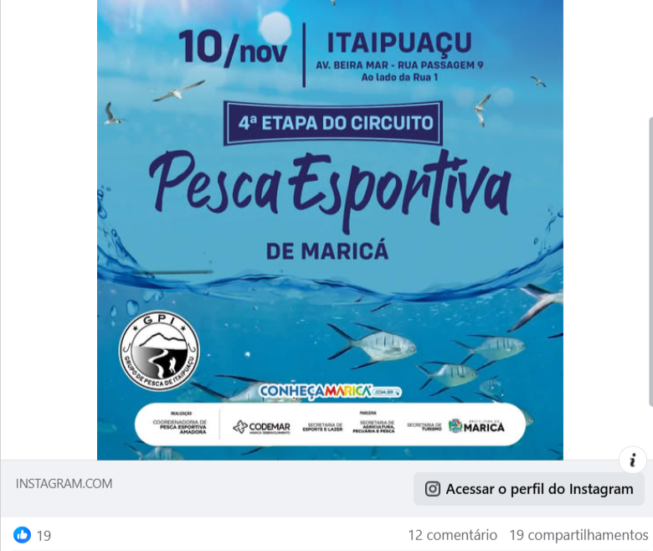

**FONTE:** [https://www.facebook.com/secretariadepescademarica/posts/pfbid0jhjhJgx6PiXNzYRsRjc9qRCg9G7FqDnm3mcZwBAFjPhtR4PCQoWGFv716Q4HoPQtl?__cft__[0]=AZVLwpu8fYG_IIoe0U-yC8ChWFAAmsxqbSFjh1SbUQwEWEGjsUGRnC9QdrqW6LcFv85hqq-JYjLG1B5tdwwVN_u_psYU0KBytYB2y3yxhvrwHx6YbvbsHTGhpX7nvYRW-ZM2v2yE_nRjXhHQsT8NP3Hyq56yTCI-ntjRwAySmrNAWrmhQdps7TKeXdCZQaFfJrg&__tn__=%2CO%2CP-R](https://www.facebook.com/secretariadepescademarica/posts/pfbid0jhjhJgx6PiXNzYRsRjc9qRCg9G7FqDnm3mcZwBAFjPhtR4PCQoWGFv716Q4HoPQtl?__cft__%5b0%5d=AZVLwpu8fYG_IIoe0U-yC8ChWFAAmsxqbSFjh1SbUQwEWEGjsUGRnC9QdrqW6LcFv85hqq-JYjLG1B5tdwwVN_u_psYU0KBytYB2y3yxhvrwHx6YbvbsHTGhpX7nvYRW-ZM2v2yE_nRjXhHQsT8NP3Hyq56yTCI-ntjRwAySmrNAWrmhQdps7TKeXdCZQaFfJrg&__tn__=%2CO%2CP-R)

