**CLIPPING DE NOTÍCIAS – CIRCUITO MARICÁ DE PESCA   
ESPORTIVA E AMADORA**

**Fonte:** [https://www.facebook.com/permalink.php?story_fbid=pfbid02syiLPiqDU2YjhkXciM1Gf6m3PFPnbVENx9cNm95X78Z7RtjNM3R3xUyy5Puapdbgl&id=100084250384005&__cft__[0]=AZXLj2nyy_0YkRpRZsmk13kIU_Z9HMZWXPbmmmd9AzQSBLwuLsnR4ZLu4crkfCGMTwfQxB5ayx3y9haBfsNjWfRYWPtNld3o_8qH-b5b_lBfzKn5uzHL5yl5CkNFFfMISch1vqehMl4ZO3-FH3VmRepsvbFcn1F4MSkBEv_5rwIDvg&__tn__=%2CO%2CP-R](https://www.facebook.com/permalink.php?story_fbid=pfbid02syiLPiqDU2YjhkXciM1Gf6m3PFPnbVENx9cNm95X78Z7RtjNM3R3xUyy5Puapdbgl&id=100084250384005&__cft__%5b0%5d=AZXLj2nyy_0YkRpRZsmk13kIU_Z9HMZWXPbmmmd9AzQSBLwuLsnR4ZLu4crkfCGMTwfQxB5ayx3y9haBfsNjWfRYWPtNld3o_8qH-b5b_lBfzKn5uzHL5yl5CkNFFfMISch1vqehMl4ZO3-FH3VmRepsvbFcn1F4MSkBEv_5rwIDvg&__tn__=%2CO%2CP-R)

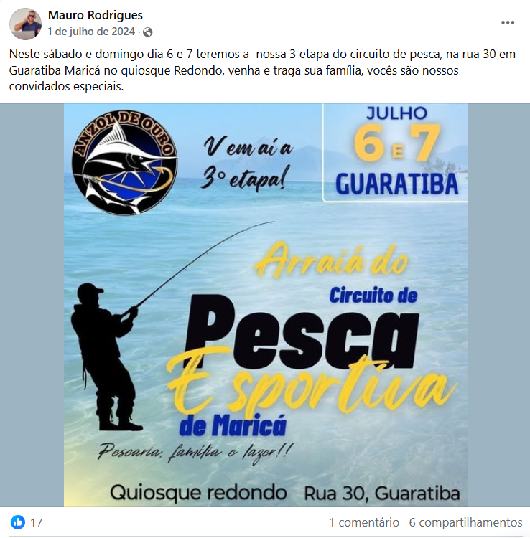

**Fonte:** [https://www.facebook.com/secretariadepescademarica/posts/pfbid02nhNwdEoPPe44ctezaxRwXKr4gdDhgJ5sJkVUFoGGpDNXzCLSMxaQPaKwHB6miUjkl?__cft__[0]=AZXkZ1zbc46LfxcVWF8Vzc29lO3ykh-L7N4kGM9B8XB0LZBnYI6vTghO6UbOA52_zOwz2TtXOBPLKKMAeFMQnGQjSRFxD7Ee-6mZ9e9AZlBNvRo38sJuTX9PB1TRYjiou5olQoR8bpCZZ7VvfTLJ2KPAqpCKKKvHR3NZxywe1hwVVaGgqzS_4EAt59XwRx8JSFE&__tn__=%2CO%2CP-R](https://www.facebook.com/secretariadepescademarica/posts/pfbid02nhNwdEoPPe44ctezaxRwXKr4gdDhgJ5sJkVUFoGGpDNXzCLSMxaQPaKwHB6miUjkl?__cft__%5b0%5d=AZXkZ1zbc46LfxcVWF8Vzc29lO3ykh-L7N4kGM9B8XB0LZBnYI6vTghO6UbOA52_zOwz2TtXOBPLKKMAeFMQnGQjSRFxD7Ee-6mZ9e9AZlBNvRo38sJuTX9PB1TRYjiou5olQoR8bpCZZ7VvfTLJ2KPAqpCKKKvHR3NZxywe1hwVVaGgqzS_4EAt59XwRx8JSFE&__tn__=%2CO%2CP-R)

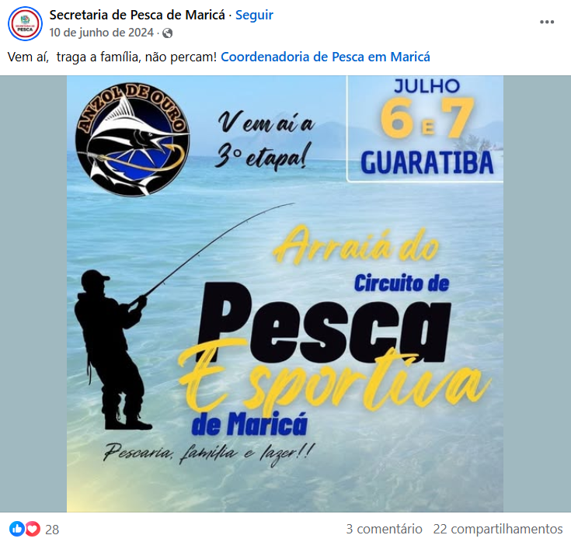

**Fonte:** <https://www.facebook.com/secretariadepescademarica/posts/pfbid031exp5ztNRmqayWDLbc7hdQTtQth7JmiMKsVUDm6WgNucR33nJALcfz4F2LmRPygBl>

