**CLIPPING DE NOTÍCIAS – CIRCUITO PESCA ESPORTIVA**

**FONTE:** <https://www.facebook.com/coordenadoriadepesca/posts/pfbid0dKBbyA1yifURn4enHAsbLJSz3PkLdzrKGY3aBB6KFC6WtKKne5A7KqSacda2bGbNl>

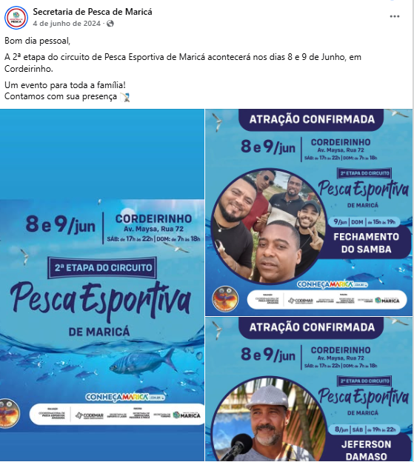

**FONTE:** <https://www.facebook.com/coordenadoriadepesca/posts/pfbid0eNLiuR2fmQvcv4E4UVXgmi46yVevgKHG1femAom3nkj863s9Xk6pG3EuNeuSuPF2l>

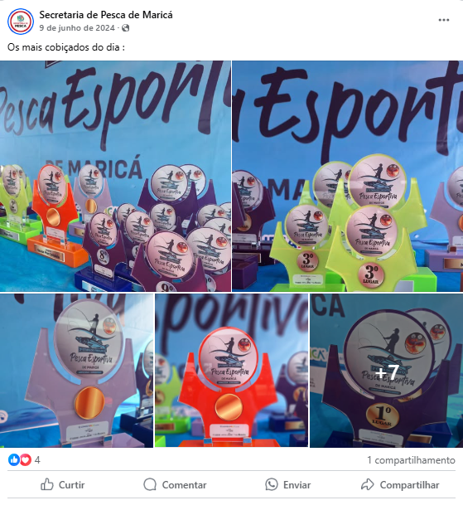

**FONTE:** <https://www.facebook.com/coordenadoriadepesca/posts/pfbid033hfu9eogh1usjKAhgeSEux2qS4FxT4gJ2smV3ACgHDgJdeNnCTwWgR6wJ46jtSJHl>

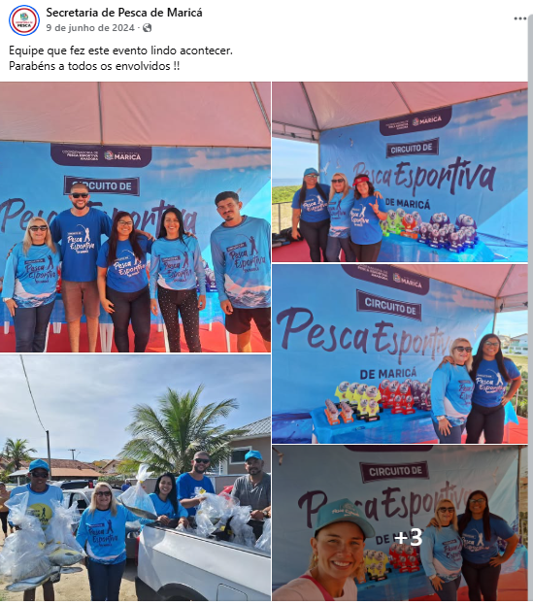

**FONTE:** <https://www.facebook.com/coordenadoriadepesca/posts/pfbid0bnPtK9n77eDFAhpAVa3mPWbuJSKmP4oyoY3a6FamQ96kR2TE7FKB1Ht3JGPgJeSyl>

