**CLIPPING NOTICIAS – FEIRA AGRICULTURA FAMILIAR – NOVEMBRO**

**ITAIPUAÇU**

**FONTE:** [**https://www.facebook.com/share/p/1AWGMm8B7L/**](https://www.facebook.com/share/p/1AWGMm8B7L/)

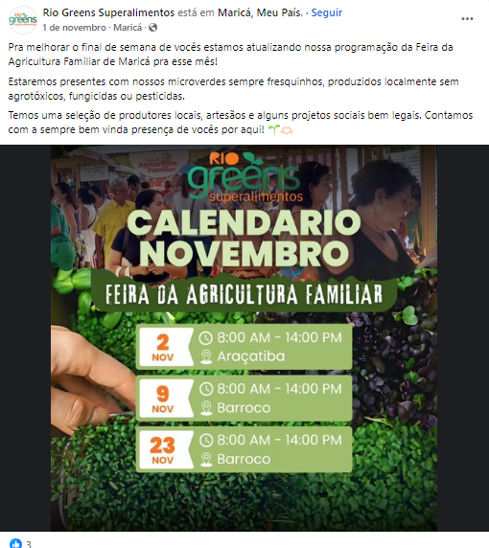

**FONTE:** [**https://www.facebook.com/share/p/18k1if6jVm/**](https://www.facebook.com/share/p/18k1if6jVm/)

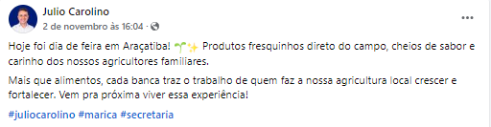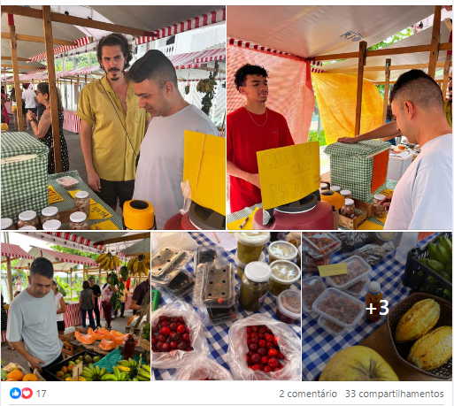

**ARAÇATIBA**

**FONTE:** [**https://www.facebook.com/share/p/17szLiB8JS/**](https://www.facebook.com/share/p/17szLiB8JS/)

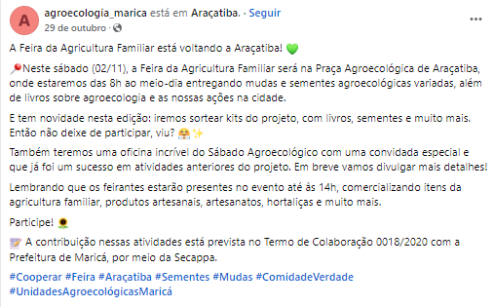

**FONTE:** [**https://www.instagram.com/p/DBtsm7iOMC9/?utm_source=ig_web_copy_link&igsh=MzRlODBiNWFlZA**](https://www.instagram.com/p/DBtsm7iOMC9/?utm_source=ig_web_copy_link&igsh=MzRlODBiNWFlZA)**==** 