CLIPPING NOTICIAS – FEIRA AGRICULTURA FAMILIAR – SETEMBRO

ITAIPUAÇU
FONTE: https://www.facebook.com/share/p/19kzAX5TnB/
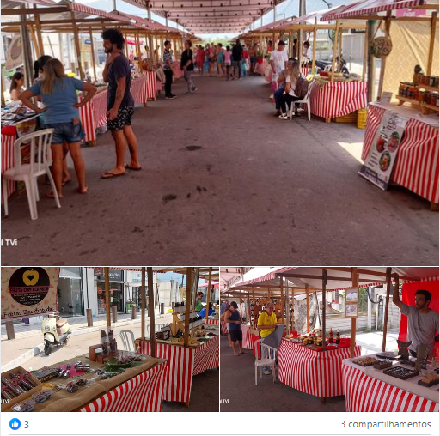

FONTE: https://www.facebook.com/share/p/19aifHjYEo/
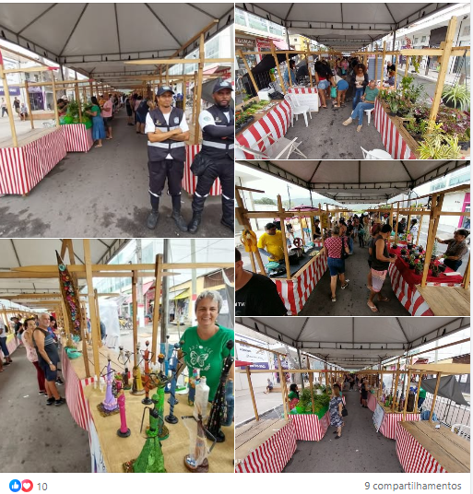

FONTE: https://www.facebook.com/share/p/1BD4x2r81y/
