CLIPPING DE NOTÍCIAS – JORNADA DE CAPACITAÇÃO
Fonte: https://www.instagram.com/p/DVrC1b5gNjs/
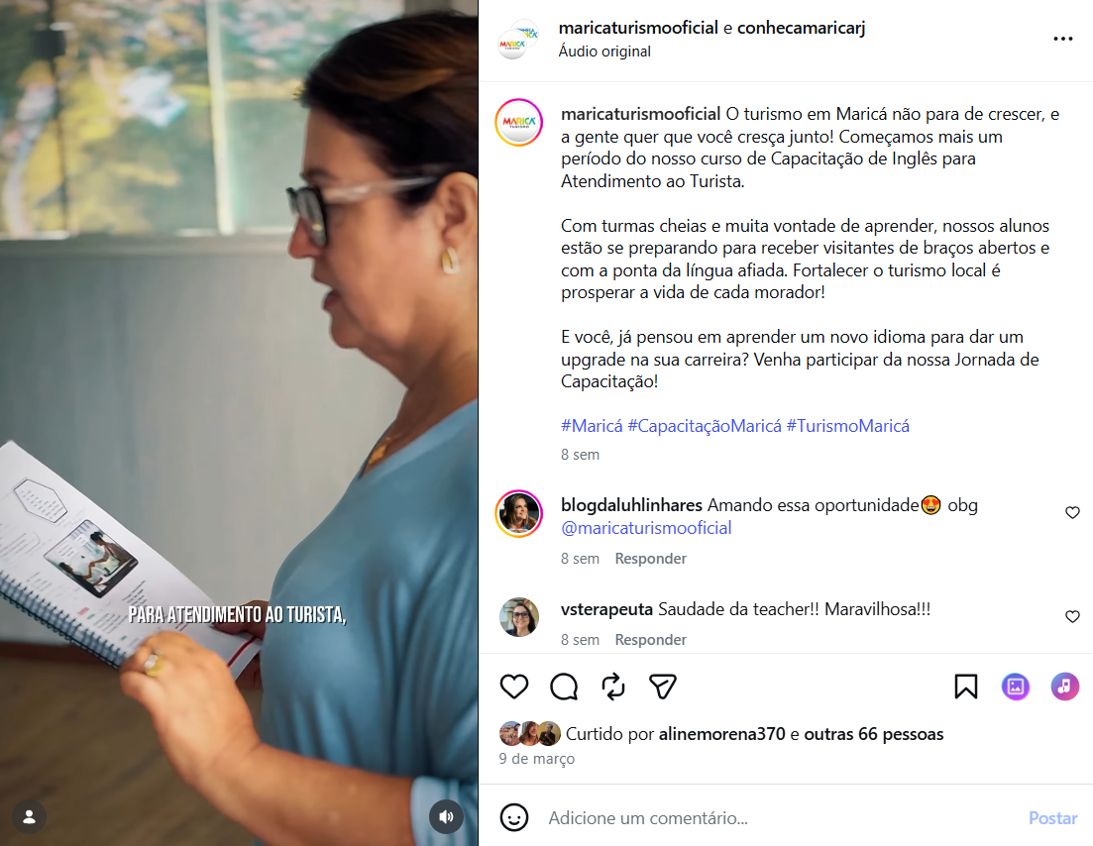

Fonte: https://www.instagram.com/p/DVL0_7NDabC/
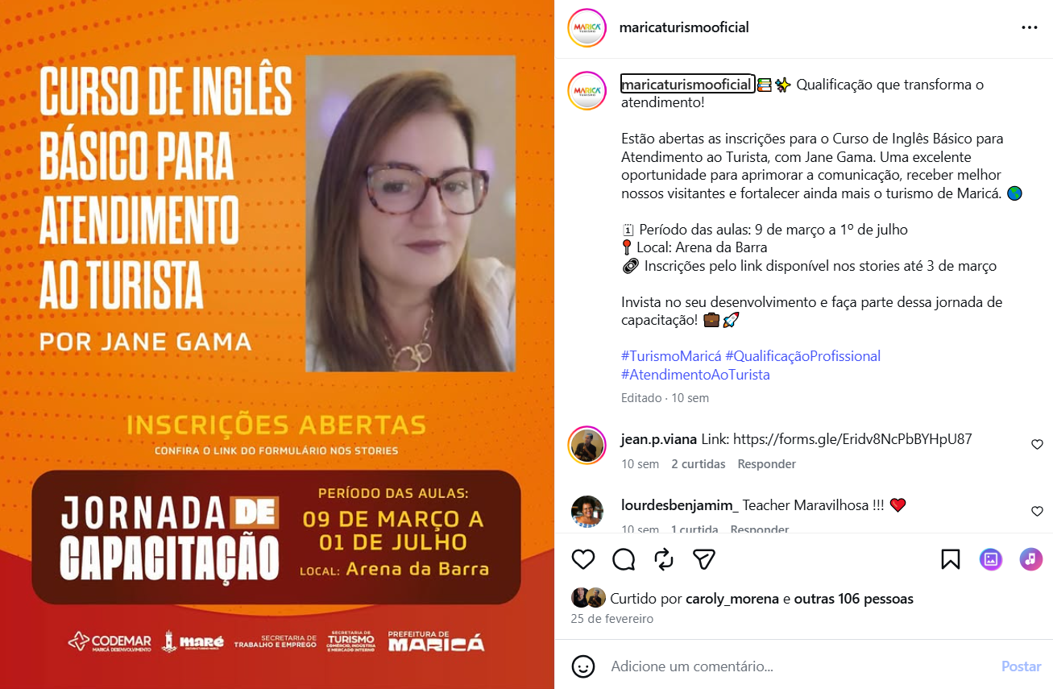
Fonte: https://www.instagram.com/p/DVhwU2XjbpH/
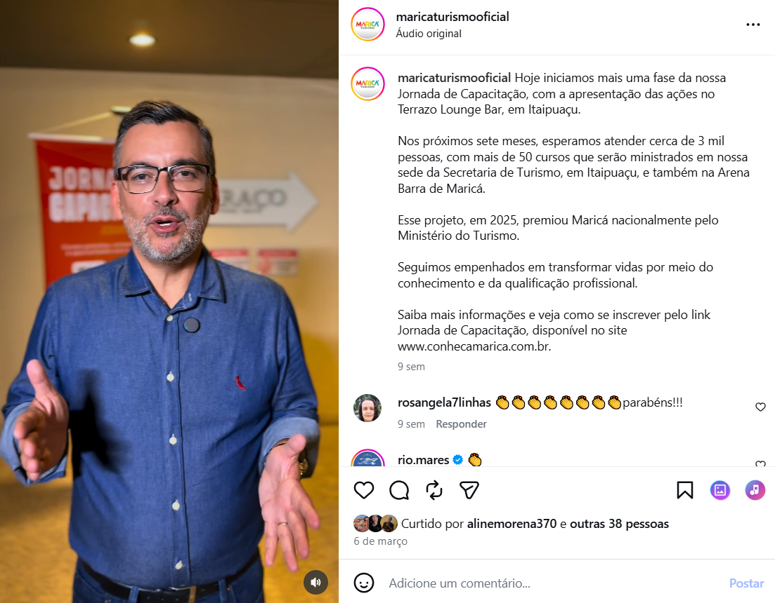
Fonte: https://www.instagram.com/p/DVroXplgB8G/
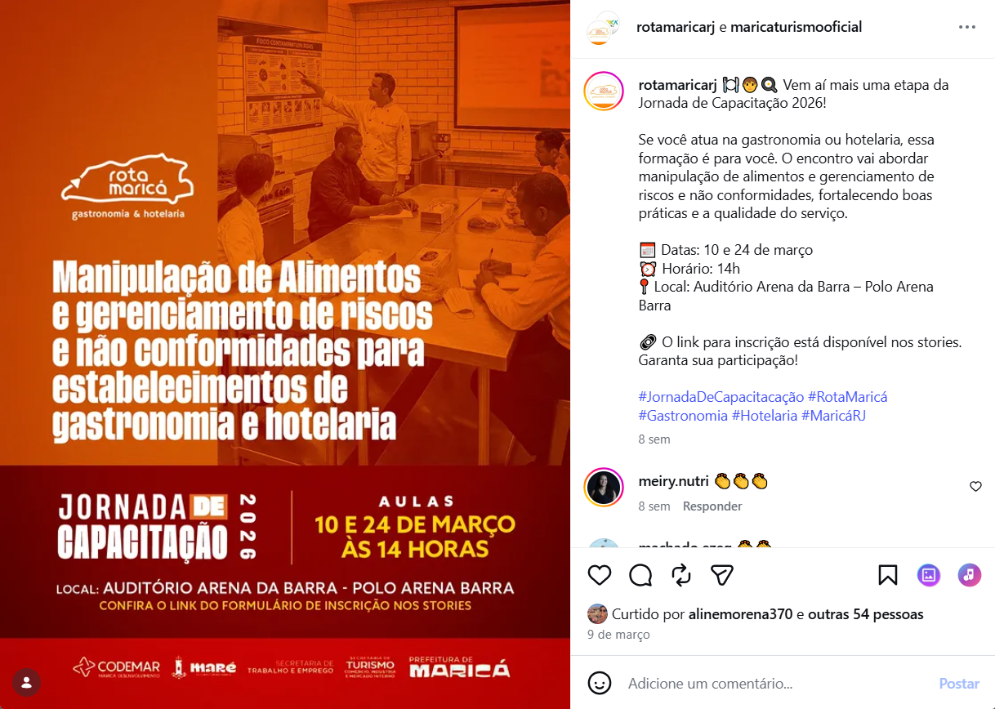
Fonte: https://www.instagram.com/p/DVtGacADQ2X/
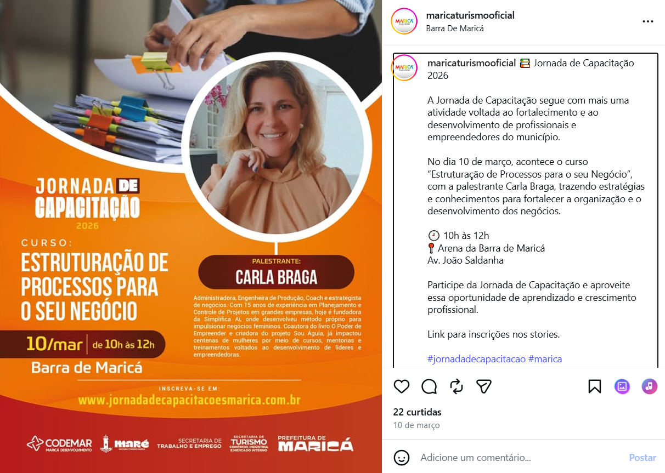

Fonte: https://www.instagram.com/p/DVtg-tPAPdQ/
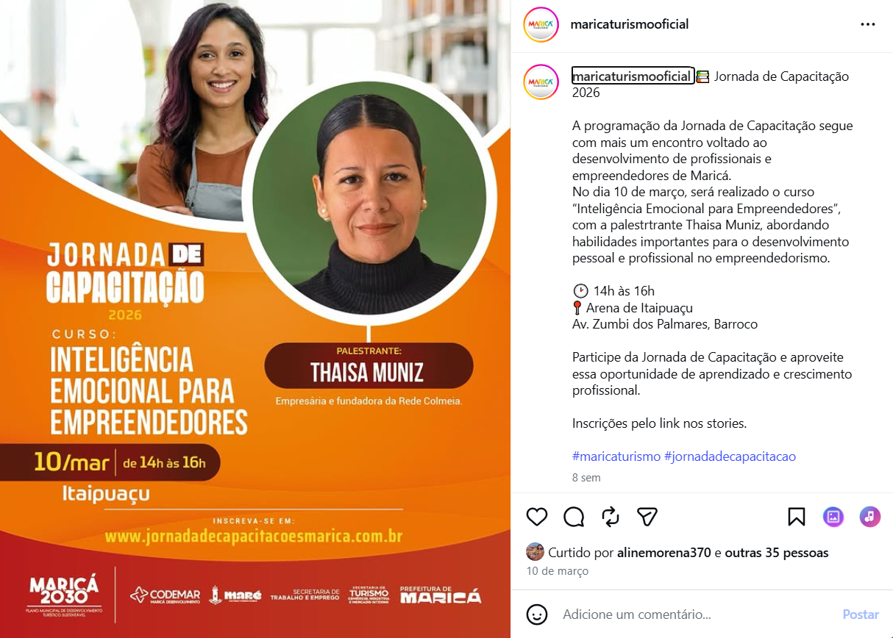
Fonte: https://www.instagram.com/p/DVuWAaOjXCK/
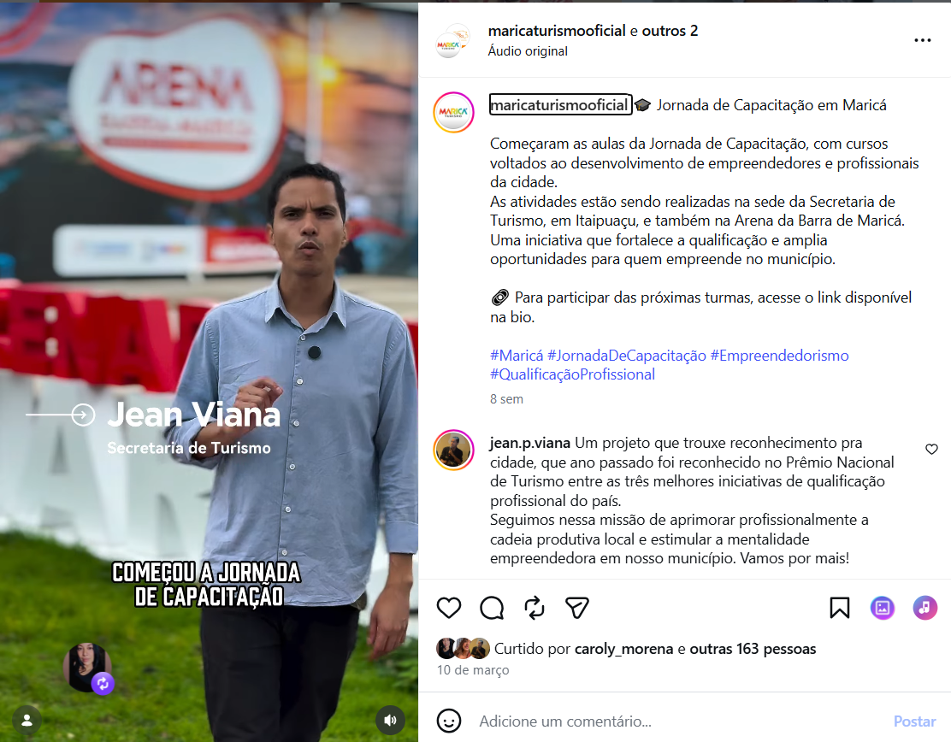

Fonte: https://www.instagram.com/p/DVwXYkDALM6/
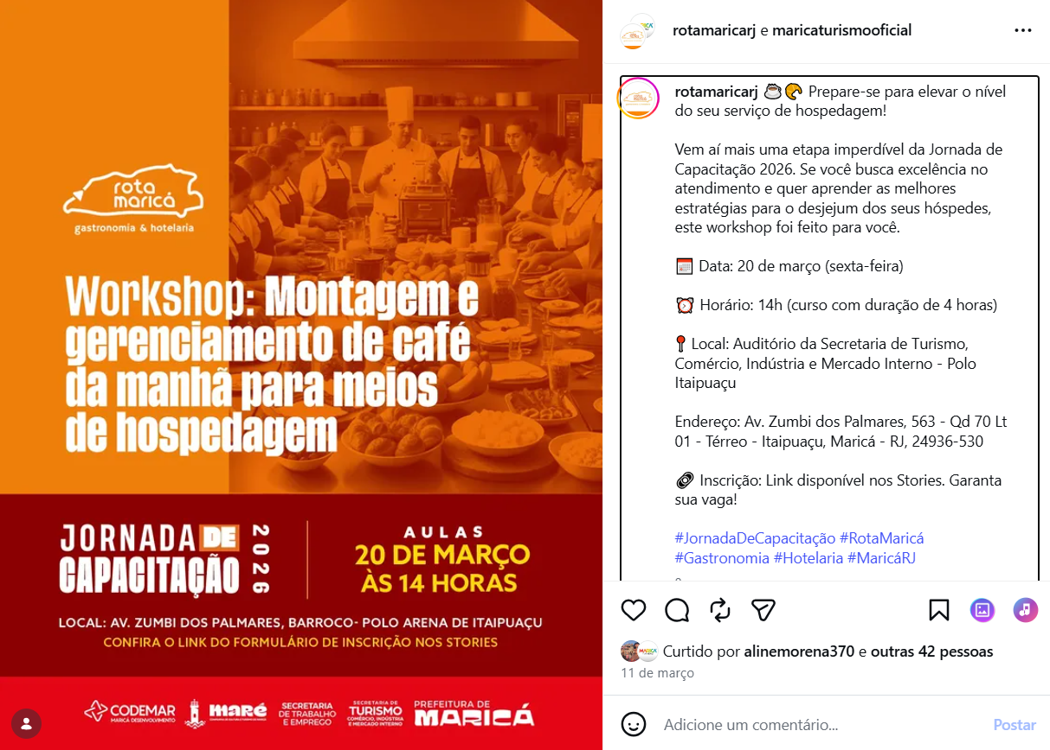
Fonte: https://www.instagram.com/p/DVwZm7SgWZT/
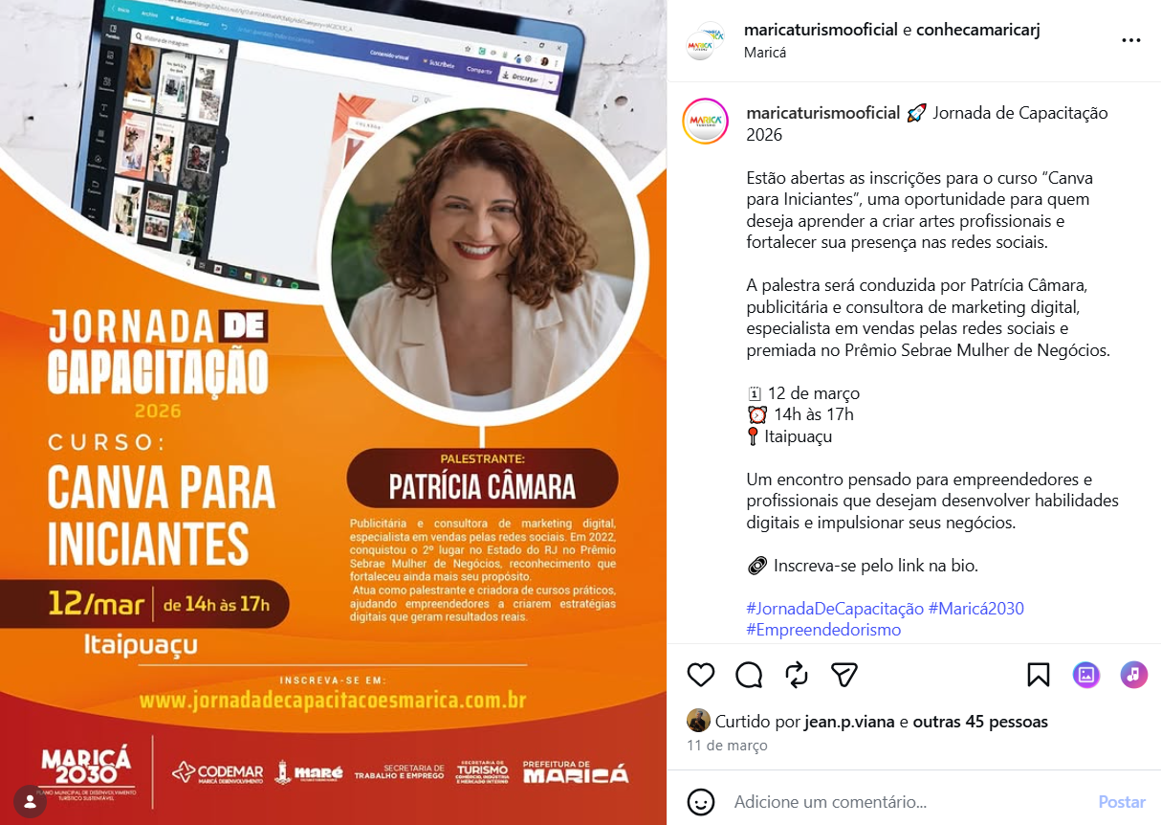

Fonte: https://www.instagram.com/p/DV158yYAfkC/
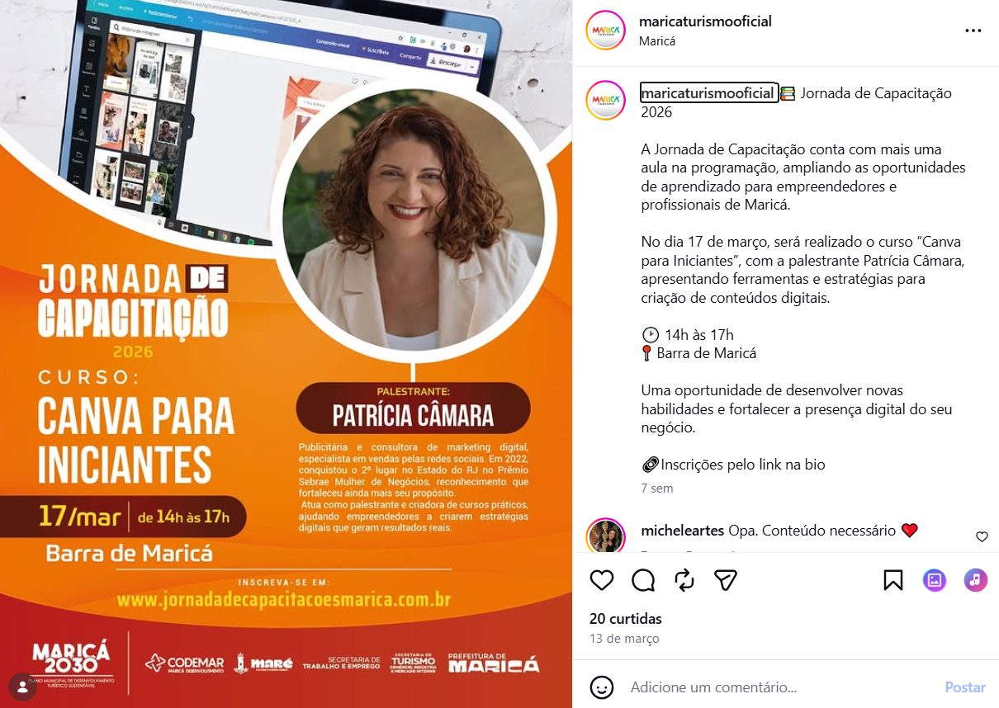
Fonte: https://www.instagram.com/p/DV3sHgWDexD/
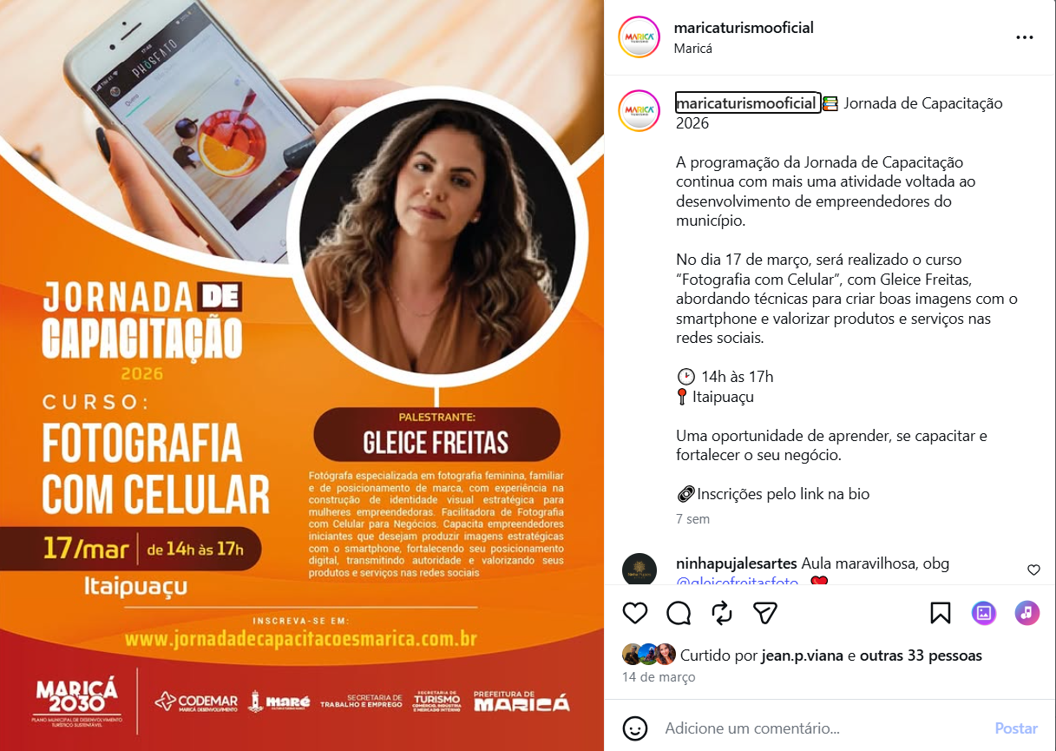

Fonte: https://www.instagram.com/p/DV37s8bgINa/
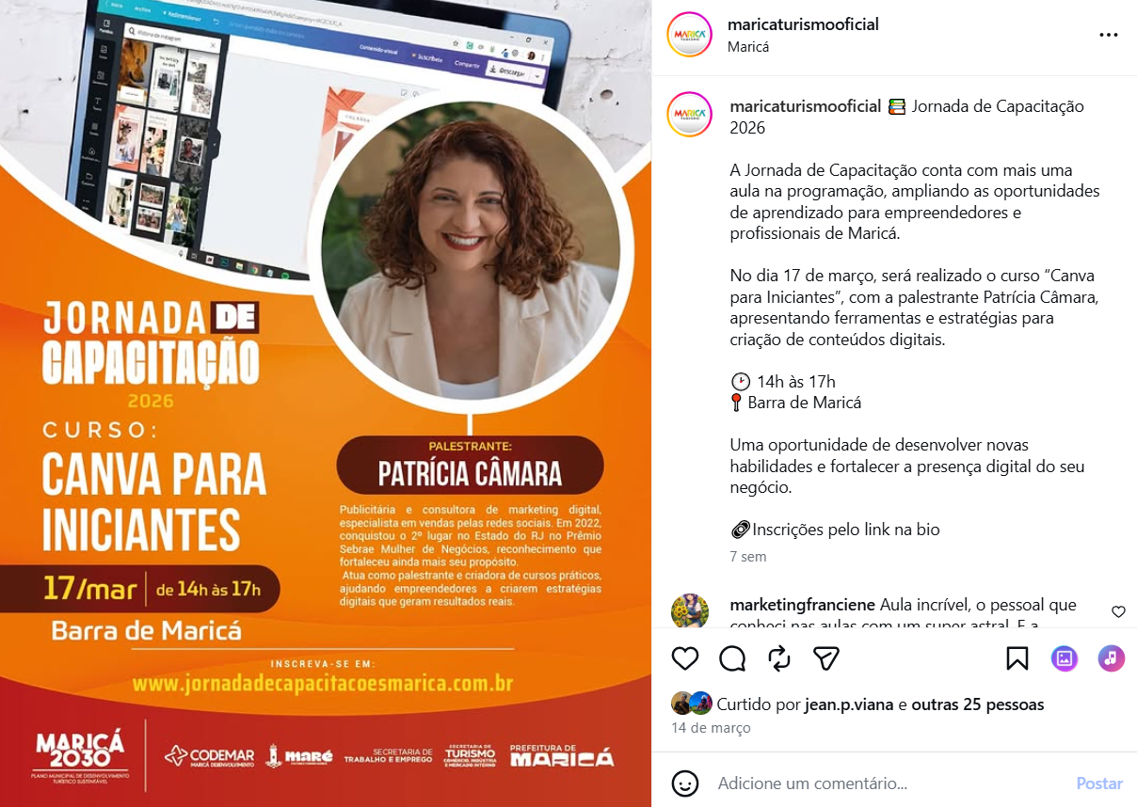
Fonte: https://www.instagram.com/p/DV4ZhfvAYNJ/
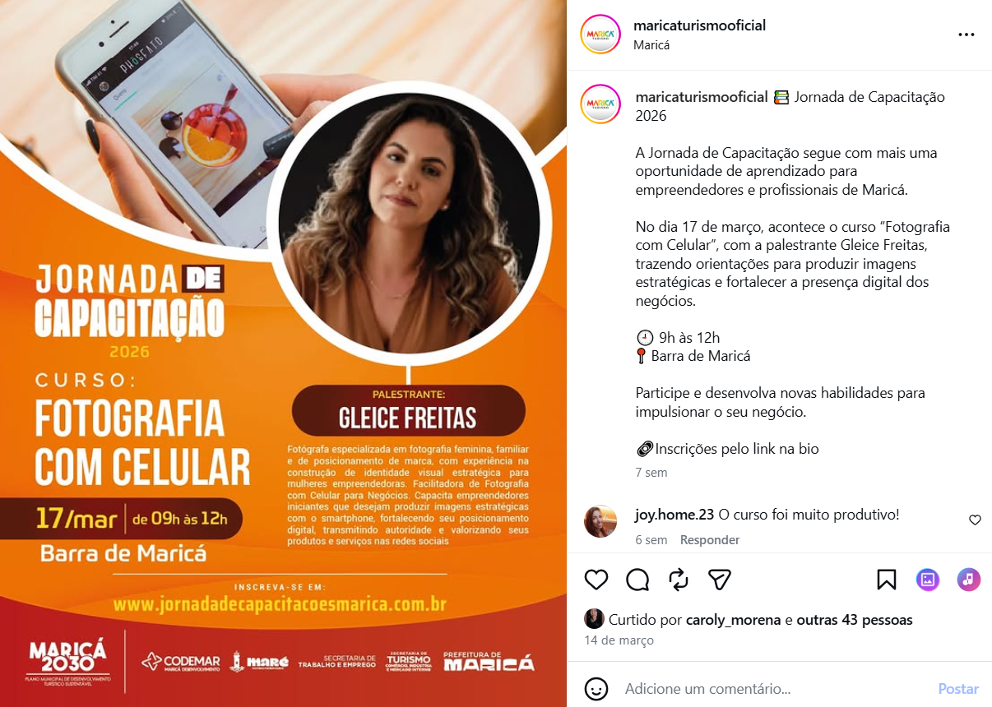

Fonte: https://www.instagram.com/p/DV9RH_Xj_o4/
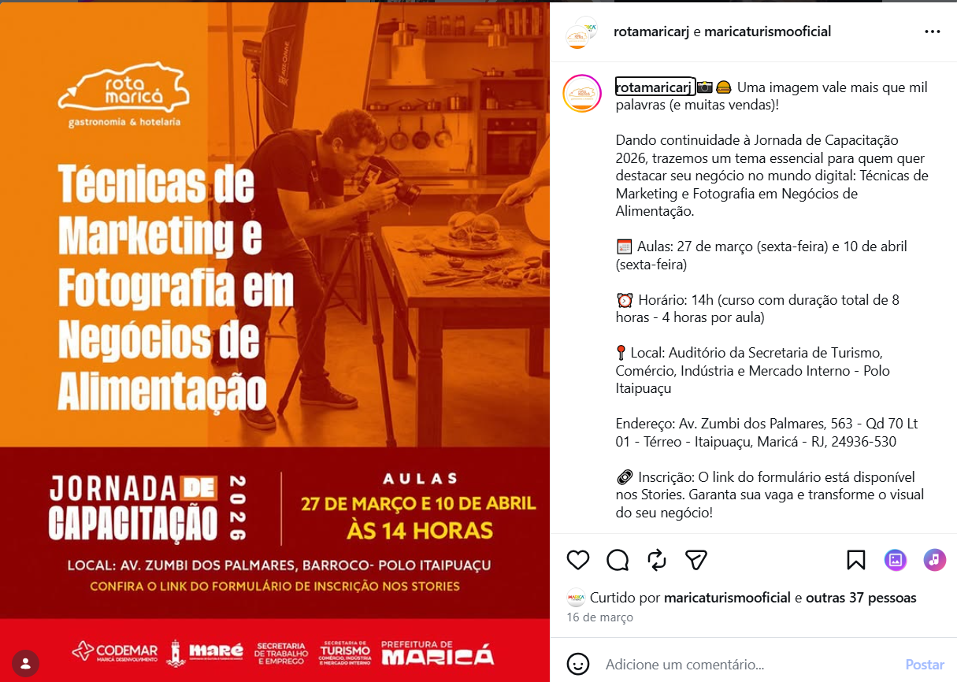
Fonte: https://www.instagram.com/p/DWOw8eCjWpH/
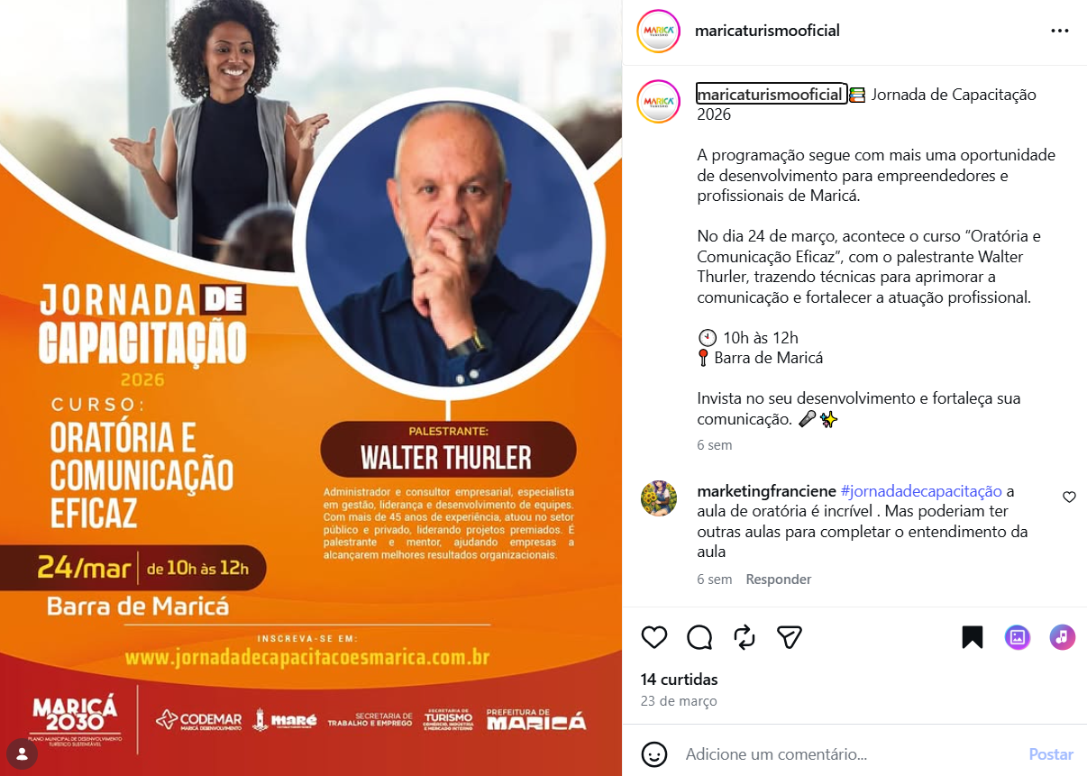

Fonte: https://www.instagram.com/p/DWUiOPDgUdB/
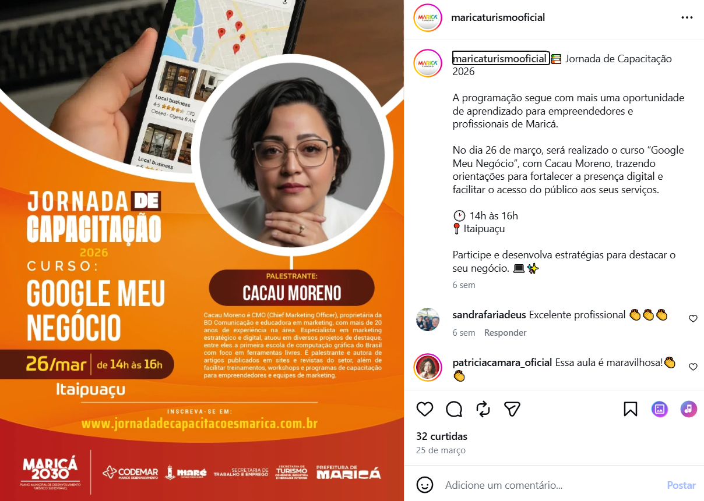
Fonte: https://www.instagram.com/p/DWzRrDSD7qc/
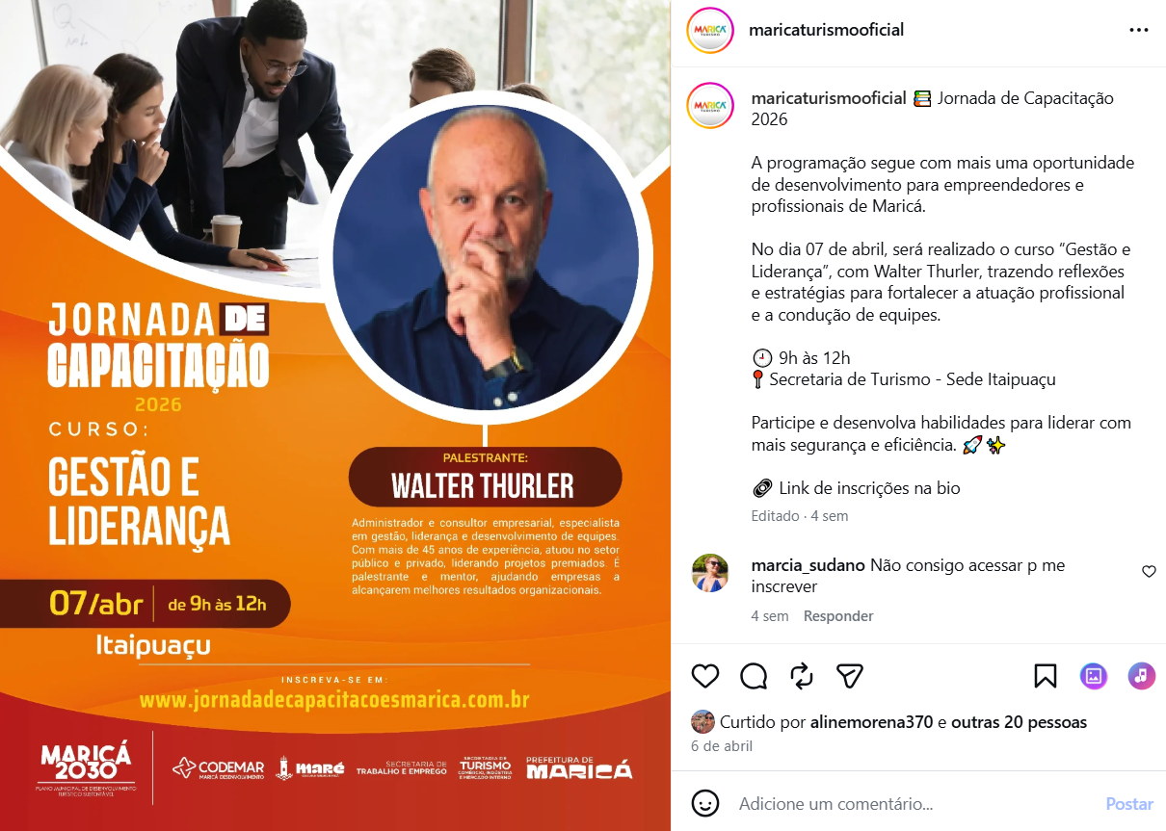

Fonte: https://www.instagram.com/p/DWzhS3tgZns/
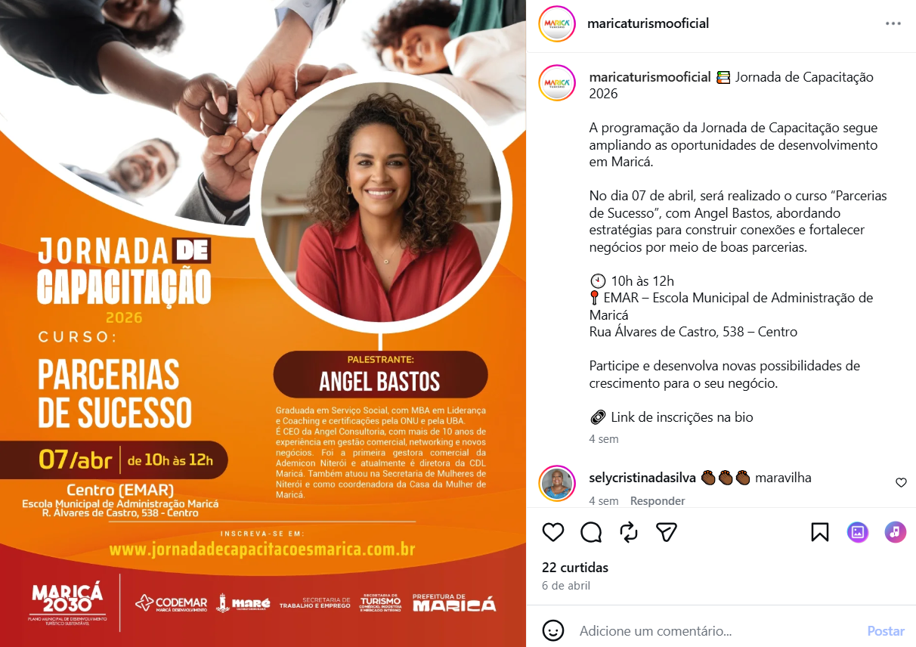
Fonte: https://www.instagram.com/p/DW1Rr0ngHCk/
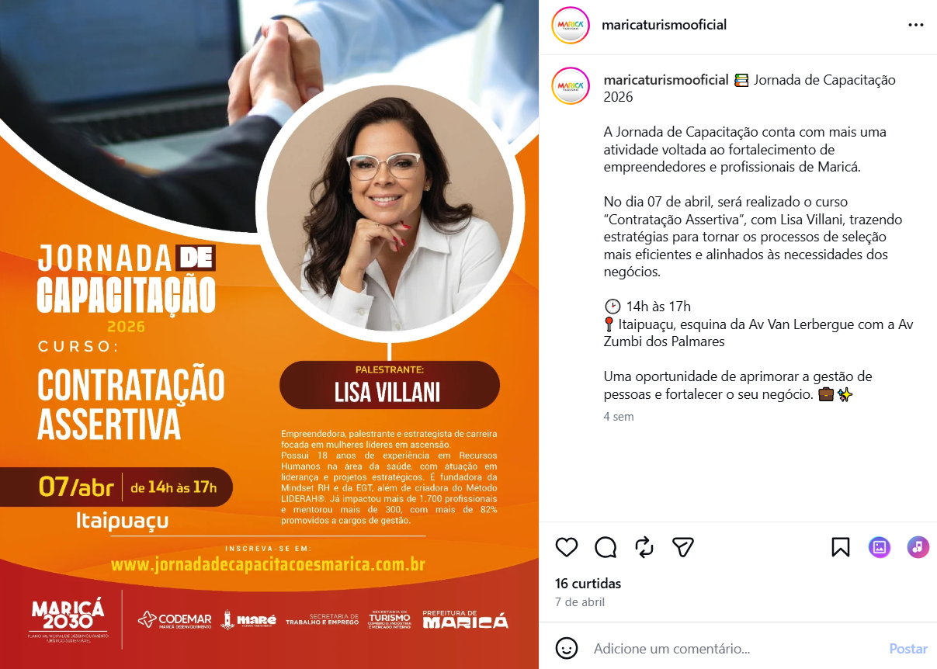

Fonte: https://www.facebook.com/photo?fbid=1026237529740079&set=a.221533653543808
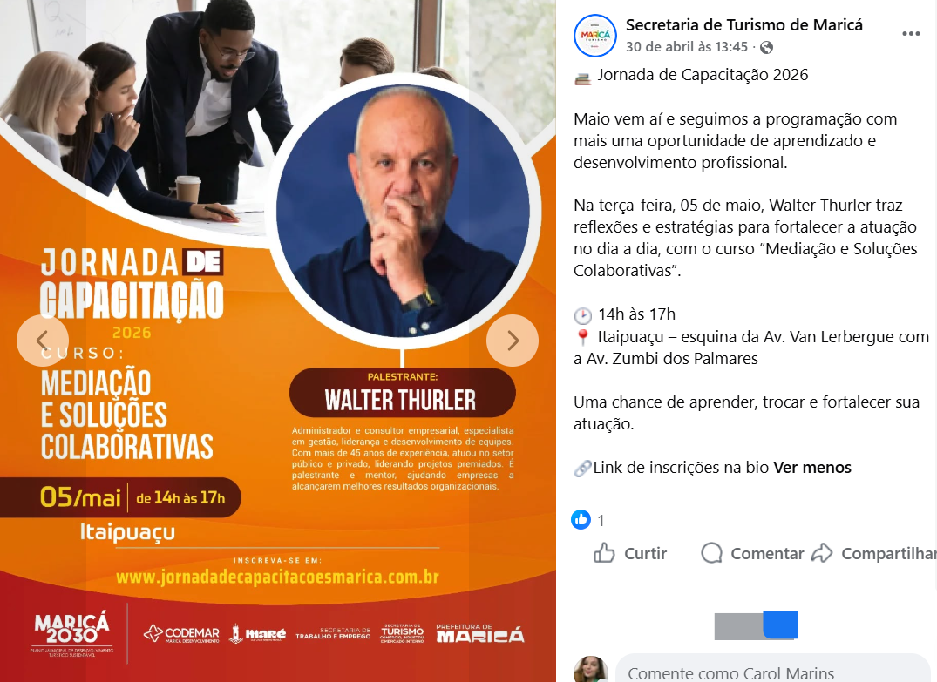

Fonte: https://www.instagram.com/reels/DVjZVDwjjju/
